# CS 255 Business Requirements Document Template

Complete this template by replacing the bracketed text with the relevant information.

This template lays out all the different sections that you need to complete for Project One. Each section has guiding questions to prompt your thinking. These questions are meant to guide your initial responses to each area. You are encouraged to go beyond these questions using what you have learned in your readings. You will need to continually reference the interview transcript as you work to make sure that you are addressing your client’s needs. There is no required length for the final document. Instead, the goal is to complete each section based on your client’s needs.

**Tip:** You should respond in a bulleted list for each section. This will make your thoughts easier to reference when you move into the design phase for Project Two. One starter bullet has been provided for you in each section, but you will need to add more.

## System Components and Design

### Purpose

What is the purpose of this project? Who is the client and what do they want their system to be able to do?

The purpose of DriverPass is to help people with passing their driving exam.

The client of DriverPass would be Liam

Liam would like a platform that can be accessed to assist with learning how to drive from the comfort of someones home.

The platform would need to be accessible to online students to study as well as be accessible for scheduling bookings for driving tests and lessons.

### System Background

What does DriverPass want the system to do? What is the problem they want to fix? What are the different components needed for this system?

* DriverPass would like the system to provide a path that will help students with showcasing good learning practices between students and driving schools.
* DriverPass wants a system that will provide an avenue where students can book driving classes in an easy and convenient way.
* DriverPass will need the system to alert them whenever a student makes a driving practice reservation.
* DriverPass needs the system to show the three package options for students to select from.
* The purpose of the system is too eliminate or curt down the growing number of failed final driving exams.
* The system comports consist of online study materials, driver details, details from the three packages DriverPass offers, and DriverPass management.

### Objectives and Goals

What should this system be able to do when it is completed? What measurable tasks need to be included in the system design to achieve this?

* When complete the system will be have many different function and roles.
* It will allow users to access online study material.
* Allow users to reserve driving lessons.
* The admin and DriverPass management will receive alerts from changes happening within the system.
* The system will be able to provide admins with constant tracking of various objects within the system that include the following:
* Cancelled number of reservations.
* Number of daily user logins (to monitor platform traffic).
* The number of reservations made.

## Requirements

### Nonfunctional Requirements

In this section, you will detail the different nonfunctional requirements for the DriverPass system. You will need to think about the different things that the system needs to function properly.

Basic computer skills and knowledge of internet.

Approximately 2gb of ram or more will be needed.

Great internet connection.

#### Performance Requirements

What environments (web-based, application, etc.) does this system need to run in? How fast should the system run? How often should the system be updated?

* System will operate on all types of windows devices.
* The system can operate on Android devices as long as the device has 500mb or more of Ram.
* The system can operate on Linux devices.
* The system will need to be updated approximately every 3 months or so.

#### Platform Constraints

What platforms (Windows, Unix, etc.) should the system run on? Does the back end require any tools, such as a database, to support this application?

* The system should function very effectively and smooth Windows, Android and Linux devices.
* The system will not require any form of backup database in order to function as normal.
* The DriverPass system is efficient enough to operate without additional software.
* The system cannot operate on mobile devices unless the device has 500mb of Ram or more.

#### Accuracy and Precision

How will you distinguish between different users? Is the input case-sensitive? When should the system inform the admin of a problem?

* The system will require a user to register with an email and the appropriate credentials.
* By using an email for registration it makes each user and their accounts different from one another which helps admins and the system distinguish each user more effectively.
* The system is case sensitive and a prompt is displayed when a user is registering.\
* An admin will be notified when a user wants to modify or change a package and if an empty queue within the reservation occurs.

#### Adaptability

Can you make changes to the user (add/remove/modify) without changing code? How will the system adapt to platform updates? What type of access does the IT admin need?

* The system will allow an admin to make system changes to the platform without having to alter the coding.
* The system will allow an admin to remove a user from the system under specific circumstances such as the user quitting the program, life changes occurs for a user or with the completion of the course for the user.
* Details of a user can only be altered if and when a user gives consent to the admin to do so.
* Once changes have been made to a users account or package the user will receive notifications of the changed that were made.

#### Security

What is required for the user to log in? How can you secure the connection or the data exchange between the client and the server? What should happen to the account if there is a “brute force” hacking attempt? What happens if the user forgets their password?

* With the systems security it will require two. Forms of authentication which are username and password.
* The system will have a “Forgot Password” ability helping users with resetting a password if they can not remember there’s.
* The security of this system will require effective application of both technical and administrative control.
* The admin will be routinely updated if a hacking attack occurs or is attempted on the system.
* The system with its password and username authentication will prevent no breach of privacy or dos attacks can occur.

### Functional Requirements

Using the information from the scenario, think about the different functions the system needs to provide. Each of your bullets should start with “The system shall . . .” For example, one functional requirement might be, “The system shall validate user credentials when logging in.”

* The system will provide learning materials and modules for exams.
* The system can store credentials for users making login faster and more convenient.
* The platform will allow communication between a user and customer service at DriverPass.
* The system will showcase the packages DriverPass offers and guide them through each package.

### User Interface

What are the needs of the interface? Who are the different users for this interface? What will each user need to be able to do through the interface? How will the user interact with the interface (mobile, browser, etc.)?

* The interface would need permission from an admin in order to execute the program.
* The users of the interface in no particular order are:
* The admin.
* Student.
* Secretary.
* Every user must sign into the system in order to facilitate the execution of the interface.
* With a good internet connection the user can interact with the system interface using a mobile platform such as a phone.

### Assumptions

What things were not specifically addressed in your design above? What assumptions are you making in your design about the users or the technology they have?

* One thing that was not addressed would be the referral program for when a system user recommends the platform to a friend.
* Some of the assumptions were that each user has a google account with an email.
* Every user will have great internet connectivity.
* That every user finds exactly what they need within one of the 3 packages DriverPass currently offers.

### Limitations

Any system you build will naturally have limitations. What limitations do you see in your system design? What limitations do you have as far as resources, time, budget, or technology?

* The system will have a very limited number of reservations because of the amount of physical cars available for booking.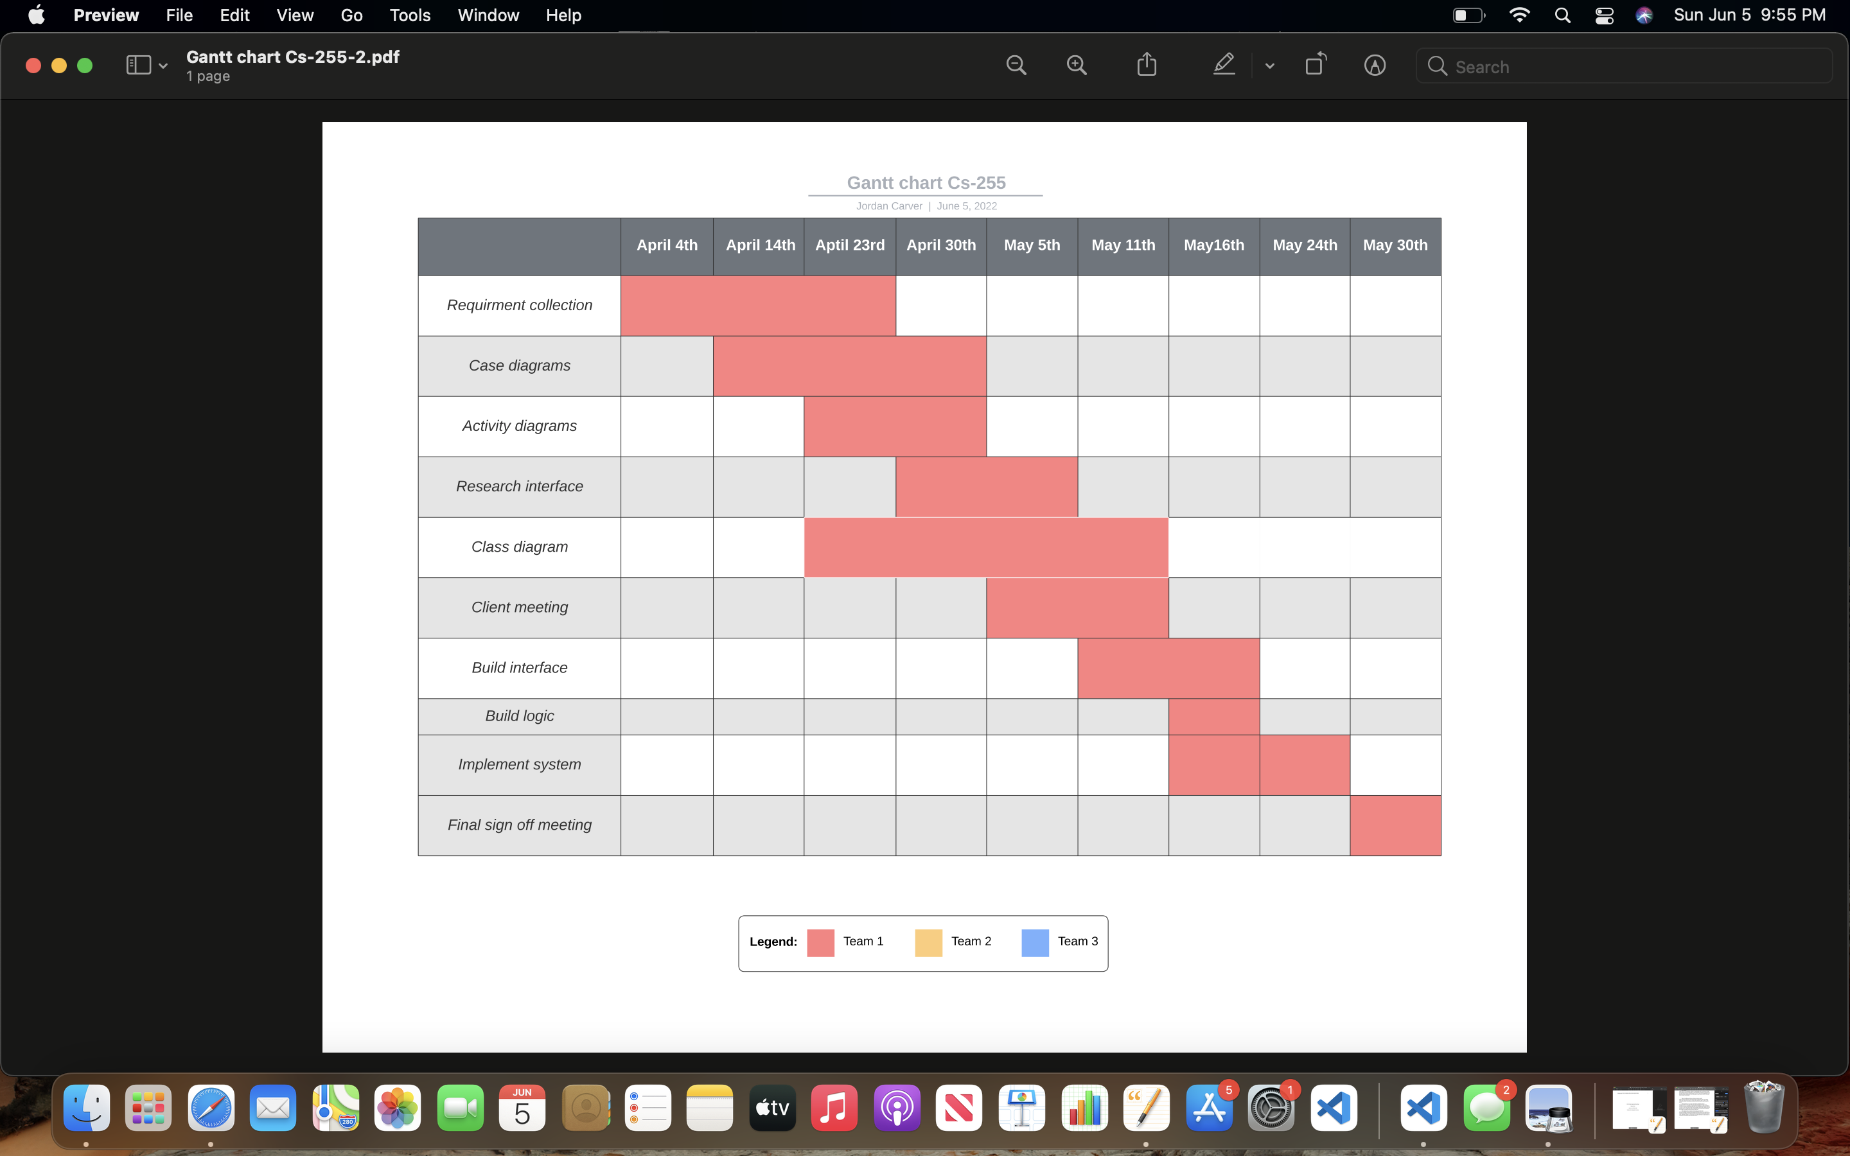
* Resources are currently maxed out at 10 vehicles with a limited number of drovers and classrooms as well.
* Budgets are limited due to their only being 3 packages to choice from due to DriverPass’s current offerings.
* The system is very limited to very good internet connectivity because system requirements require no less than 500MB of ram to operate fully.

### Gantt Chart

Please include a screenshot of the GANTT chart that you created with Lucidchart. Be sure to check that it meets the plan described by the characters in the interview.